Cointegration and ECM: USDJPY and USDCHF
Method 27 / Engle-Granger on log closes / one-lag ECM / Alpari D1 full available history

Study setup
Logical pair: PX=USDJPY , PY=USDCHF
Broker symbols: USDJPY_i , USDCHF_i
Snapshot: 2026-11-03_majors_alpari_D1
Timeframe: D1
Matched window: 1999-01-05 to 2026-11-02 (UTC bar dates)
Matched level count n: 7185
Dropped unfinished last bar dated 2026-11-03 UTC after a tick-volume check against the prior complete day.
ECM lags of deltas: 1
Complete matched rows (Excel): USDJPY-USDCHF_Coint_D1.xlsx
Complete matched rows (HTML table): USDJPY-USDCHF_Coint_D1_data.html

Method carried forward
Engle-Granger cointegration works on log price levels, not returns. For each unordered pair, PX is the left leg and PY the right leg. Step one: OLS ln(PY) = alpha + beta * ln(PX) + e. Step two: statsmodels Engle-Granger coint test on (ln(PY), ln(PX)). Error-correction: delta ln(PY)_t = c + kappa * e_{t-1} + lagged delta ln(PY) and delta ln(PX) (one lag each) + u_t. Headline is the Engle-Granger p-value (lower = stronger evidence of a stationary spread) with kappa and beta reported alongside. Same-sample Pearson r of log returns is a side check only. beta is not an automatic lot-size hedge. This is not a trading signal.

Results (headline)
alpha: 0.280684
beta: -0.044731
Engle-Granger t: -1.281934
Engle-Granger p: 0.835121
5% critical value: -3.336981
ECM kappa: -0.000446
kappa t-stat: -1.2071
ECM R^2: 0.002087
spread std: 0.210442
Pearson r (returns): 0.399461

Conclusion
Engle-Granger for PY=USDCHF on PX=USDJPY: beta=-0.0447, alpha=0.2807, coint_t=-1.2819, p=0.8351 (5% crit=-3.3370). ECM kappa=-0.0004 (t=-1.21). Pearson r of returns = 0.3995. beta is not a lot-size hedge. Not a trading signal.

Charts
Daily closes

Engle-Granger residual spread
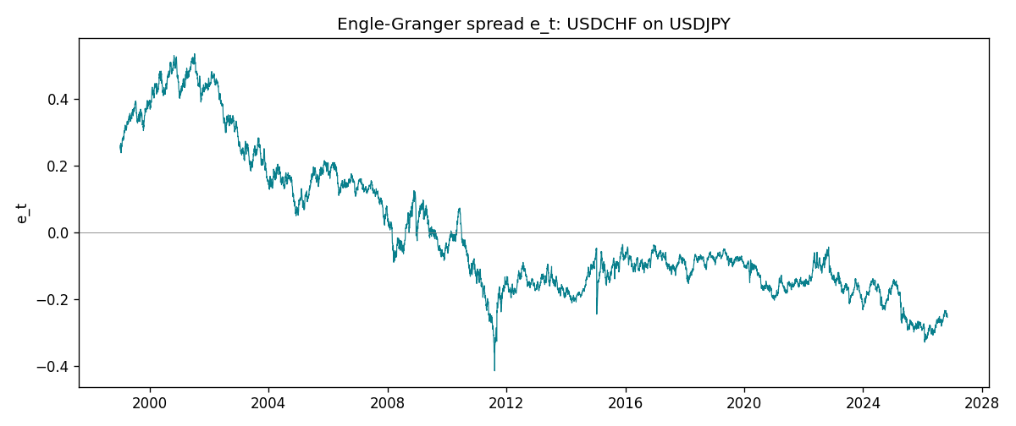
Daily log returns
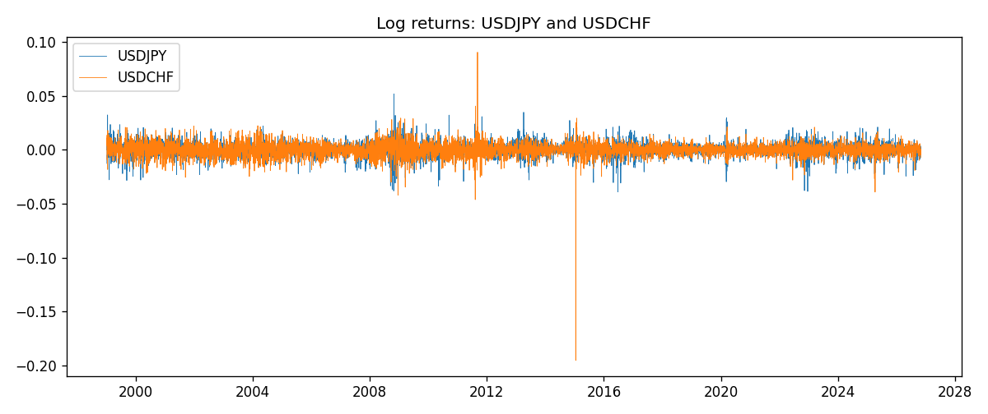

Data report
Matched rows are in the sibling Excel workbook named USDJPY-USDCHF_Coint_D1.xlsx. Embedding all rows as a Word table is impractical; this file holds column summaries and the first and last 15 matched rows.
Column summaries
column | count | mean | std | min | 25% | 50% | 75% | max
USDJPY_open | 7185 | 113.80726 | 19.2236 | 75.693 | 104.38 | 110.984 | 120.69 | 163.824
USDCHF_open | 7185 | 1.0974395 | 0.25223318 | 0.72022 | 0.92053 | 0.98988 | 1.2375 | 1.8219
USDJPY_high | 7185 | 114.30433 | 19.285132 | 76.001 | 104.865 | 111.442 | 121.257 | 163.978
USDCHF_high | 7185 | 1.1027315 | 0.25397793 | 0.73305 | 0.92474 | 0.99353 | 1.2422 | 1.8313
USDJPY_low | 7185 | 113.28455 | 19.151449 | 75.402 | 103.87 | 110.53 | 120.17 | 163.628
USDCHF_low | 7185 | 1.0923205 | 0.25064913 | 0.08565 | 0.91719 | 0.98622 | 1.2315 | 1.8121
USDJPY_close | 7185 | 113.82023 | 19.238853 | 75.811 | 104.38 | 111.025 | 120.68 | 163.851
USDCHF_close | 7185 | 1.0974333 | 0.25214008 | 0.72025 | 0.92079 | 0.98995 | 1.2376 | 1.8217
USDJPY_tick_volume | 7185 | 106345.59 | 179437.4 | 149 | 9958 | 53202 | 92889 | 1803508
USDCHF_tick_volume | 7185 | 74334.331 | 113494.7 | 18 | 12809 | 40241 | 70443 | 858589
USDJPY_spread | 7185 | 20.263883 | 17.612444 | 0 | 6 | 11 | 30 | 50
USDCHF_spread | 7185 | 26.03215 | 24.694045 | 0 | 5 | 16 | 50 | 100
USDJPY_real_volume | 7185 | 3.4781051e+10 | 1.6093614e+11 | 0 | 0 | 0 | 0 | 3.8834203e+12
USDCHF_real_volume | 7185 | 2.3294091e+10 | 8.9133595e+10 | 0 | 0 | 0 | 0 | 1.9331921e+12
USDJPY_log_price | 7185 | 4.7205292 | 0.16793031 | 4.3282434 | 4.6480381 | 4.7097554 | 4.7931424 | 5.0989575
USDCHF_log_price | 7185 | 0.06952849 | 0.21057633 | -0.32815691 | -0.08252328 | -0.01010084 | 0.21317402 | 0.59977013
USDJPY_log_return | 7185 | 4.82e-05 | 0.00620617 | -0.03908203 | -0.00320044 | 0.00011473 | 0.00340924 | 0.05184024
USDCHF_log_return | 7185 | -6.962e-05 | 0.0065941 | -0.19545699 | -0.0033516 | 8.06e-05 | 0.00332472 | 0.09051364
spread_e | 7185 | -0 | 0.21044231 | -0.41459252 | -0.15363356 | -0.08009208 | 0.14378713 | 0.53389163
ecm_fitted | 7184 | -7.018e-05 | 0.00030125 | -0.0031482 | -0.00023763 | -7.035e-05 | 9.566e-05 | 0.00670678
First 15 matched rows (selected columns)
time | USDJPY_log_price | USDCHF_log_price | spread_e | USDJPY_log_return | USDCHF_log_return
1999-01-05 | 4.7177843 | 0.31656103 | 0.24690976 | -0.00017868311 | 0.0039424743
1999-01-06 | 4.7253503 | 0.33016668 | 0.26085385 | 0.0075660159 | 0.013605652
1999-01-07 | 4.7124988 | 0.3207783 | 0.2508906 | -0.012851583 | -0.0093883841
1999-01-08 | 4.7077268 | 0.33181857 | 0.26171741 | -0.0047719894 | 0.011040268
1999-01-11 | 4.6915314 | 0.33711489 | 0.26628929 | -0.016195423 | 0.0052963193
1999-01-12 | 4.7238417 | 0.32728733 | 0.25790701 | 0.032310364 | -0.0098275602
1999-01-13 | 4.731979 | 0.30902763 | 0.2400113 | 0.0081373171 | -0.018259701
1999-01-14 | 4.731979 | 0.30660196 | 0.23758563 | 0 | -0.0024256692
1999-01-15 | 4.7375134 | 0.32454424 | 0.25577547 | 0.0055343401 | 0.01794228
1999-01-18 | 4.737601 | 0.3213586 | 0.25259375 | 8.7600193e-05 | -0.0031856384
1999-01-19 | 4.731979 | 0.32128608 | 0.25226976 | -0.0056219403 | -7.2518946e-05
1999-01-20 | 4.726591 | 0.32851207 | 0.25925473 | -0.0053879917 | 0.0072259871
1999-01-21 | 4.7350574 | 0.3246888 | 0.25581018 | 0.0084664056 | -0.0038232689
1999-01-22 | 4.7410987 | 0.32454424 | 0.25593585 | 0.0060412564 | -0.0001445609
1999-01-25 | 4.7337393 | 0.32699893 | 0.25806135 | -0.0073594164 | 0.0024546976
Last 15 matched rows (selected columns)
time | USDJPY_log_price | USDCHF_log_price | spread_e | USDJPY_log_return | USDCHF_log_return
2026-10-13 | 5.0645236 | -0.18339413 | -0.23753533 | -0.0018932826 | -0.0024955621
2026-10-14 | 5.0645994 | -0.1804553 | -0.2345931 | 7.5800166e-05 | 0.0029388325
2026-10-15 | 5.0627469 | -0.19024083 | -0.2444615 | -0.0018524319 | -0.0097855323
2026-10-16 | 5.0623672 | -0.19386391 | -0.24810157 | -0.00037976126 | -0.0036230826
2026-10-19 | 5.0658618 | -0.19022874 | -0.24431007 | 0.0034946841 | 0.0036351779
2026-10-20 | 5.0636072 | -0.19285686 | -0.24703905 | -0.0022546642 | -0.0026281224
2026-10-21 | 5.0632783 | -0.19325713 | -0.24745403 | -0.00032883504 | -0.00040027413
2026-10-22 | 5.0546841 | -0.19806077 | -0.2526421 | -0.0085942669 | -0.0048036381
2026-10-23 | 5.0550349 | -0.19240826 | -0.24697389 | 0.00035080446 | 0.005652514
2026-10-26 | 5.0591588 | -0.19056746 | -0.24494863 | 0.0041238746 | 0.0018407959
2026-10-27 | 5.0619239 | -0.18795741 | -0.24221489 | 0.0027651658 | 0.0026100526
2026-10-28 | 5.0609671 | -0.18897162 | -0.2432719 | -0.00095679538 | -0.0010142111
2026-10-29 | 5.0605867 | -0.19383964 | -0.24815693 | -0.00038043789 | -0.0048680164
2026-10-30 | 5.059527 | -0.19312369 | -0.24748839 | -0.0010596481 | 0.00071594559
2026-11-02 | 5.0621709 | -0.20026966 | -0.2545161 | 0.0026438521 | -0.0071459744

